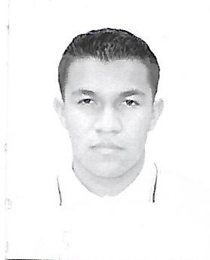Jesús Reyes Santos

Benito Juárez Street #2

C.P. 38790 Col. La Virgen Tarandacuao, Guanajuato.

Birthdate: November 26, 1996.

Age: 21 years.

Civil Status: Single.

Phone Number: 4211038049 Cell phone number. 4171058724

Email: [jesusreyes.jr92@gmail.com](mailto:jesusreyes.jr92@gmail.com)

CURP: RESJ961126HGTYNS06

Mexican Nationality.

Personal Goal

With the passage of time acquire new knowledge as the technology is updated to develop these put into practice.

Profesional Objetive

Putting my knowledge into practice and developing them at work in an excellent way, as well as strengthening myself day by day to obtain new knowledge and keep growing in the workplace.

Academic Record

Engineer in Information Technology and Communication Universidad Tecnológica de León.

Title received: Engineer in Information and Communication Technologies.

Acámbaro, Guanajuato

Period September 2017 - currently studying

Higher University Technician in Information and Communication Technologies Specialization Multimedia and Electronic Commerce Universidad Tecnológica de León.

Title received: Advanced University Technician in Multimedia and Electronic Commerce.

Acámbaro, Guanajuato

Period September 2015 - August 2017

Technician in support and maintenance of computer equipment: College of Scientific and Technological Studies of the State of Guanajuato.

Title received: Certificate.

Tarandacuao, Gto.

Period 2012 – 2015

Mahatma Gandhi High School

Title Received: Certificate.

Tarandacuao, Gto.

Period 2009-2012

Work experience

Fish and Seafood La Abuela Valeria.

Employee.

September 11, 2004 - current.

Clean fish to sell it fresh.

Ice the fish

Load vans with product.

Further training

Certificate of Labor Competence Level 2 certified worker supported by the government of the State of Guanajuato.

Certificate of basic networks by Fundamentals of networks.

Courses of local area networks with cisco.

Participation in programming competitions.

Languages

Spanish mother tongue

English medium level.

Skills and Knowledge

Management and knowledge in Linux, Windows and Mac operating system.

Handling Word, Excel, and PowerPoint.

Management and knowledge of different programs for image, audio and video editing.

Knowledge in PHP and Java programming languages, as well as the use of Management Systems and contents and Framework in PHP CodeIgniter.

Management and knowledge of programs for the development of MySQL database.

Management and knowledge for the development and documentation of a software project.

**Additional or interesting formations**

I have skills to understand the English language well in written form, it should be noted that I have the ability to deal with people and thus explain and convince them of any situation, in addition to quickly adapt to the way of working quickly and resources that are presented.

Others

I have availability to travel.

I have an elector's credential.

I have a driver's license.

I have a military license number registration number D-3733187